Master Catechist Renewal Form
Archdiocese of San Francisco -Office of Faith Formation

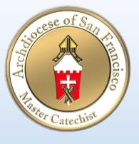
Renewal of certification happens every three years
Name _______________________________________ Date of last certification ________________
Address ______________________________________City ____________ Zip _________________
Phone _____________________ Email _____________________ Parish _______________________
Every year 10 hours of study is required
I course from Boston College Crossroads or 2 webinars must be included
Attend 2 Faith Formation Conferences in bay area
Title | Place | Presenter | # Hours
Classes taught 3-6 hours per year in basic certification
Class title | To Whom & where | # of hours

Return to : Office of Faith Formation, One Peter Yorke Way, SF 94109 Fax: 4154-614-5650

